Year 2 Homework Grid
Dungeons & Dragons – Spring Term
Literacy, Language, Communication  English:  Write you own story about a Dragon! Can you give it a name? What will your story be about? Is you dragon on an adventure or is your dragon lost?  Cymraeg:  Draw and label the colours of the rainbow (enfys).  Spanish:  Can you find what dragon is in Spanish? | Expressive Arts:  Can you design and draw your own dragon?  Here is a link to Art with Kids. Can you use this video to help you?  https://youtu.be/KRAarF177Y4  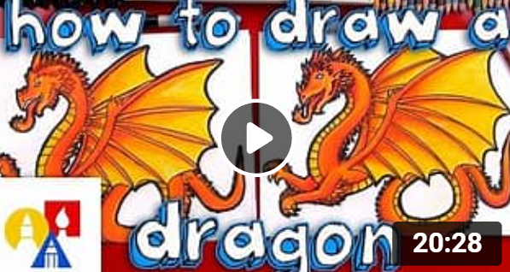 |  | Humanities  Can you find Cardiff Castle on a map?  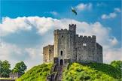
Digital Competence:  Can you use www.plotz.co.uk to make a Minecraft castle? Try to use and follow one of the other amazing tutorials on their website!  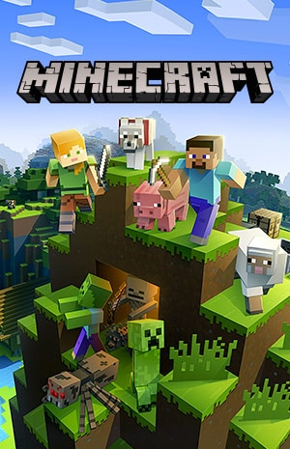 | Science & Technology:  This term we’re looking at forces.  Search around your house, can you find 5 objects/things that need to be pushed and 5 objects/things that need to be pulled?  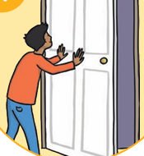  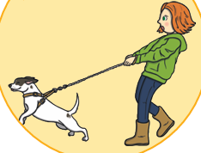  Pull Push |  | Maths & Numeracy:  Can you start to practising subtraction?  https://www.topmarks.co.uk/Search.aspx?q=subtracting  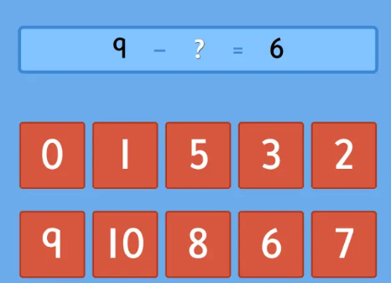
Health & Wellbeing  Can you make your own mini-circuit to impress Mr Smith? Don’t forget to take some fab pictures!  Try to include some exercises like:  -Star jumps  -Press ups  -Step ups  -Sit ups  -Two footed jumps  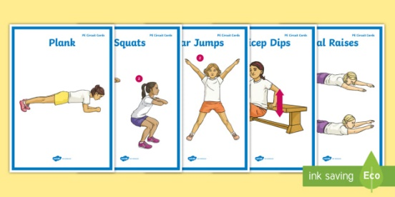 |  |   Don’t forget to read every night!

